The T7 System

The T7 system in its current – and – past – 2014 version – is inherently unfair in the sense that clients at a higher level in the hierarchy are allowed facilities which are orders of magnitude larger than those at the lowest level. From the point of mobile app users – the system amounts to criminal breach of trust. The unbelievable fact is that not a single client has raised this inherent unfairness issue at the government level of the Ministry of Finance. And this rot – is deployed across most major exchanges globally Are SEBI and the MoF aware of the issues - and what is their opinion in this matter - there has been no concealment of facts directly - but the common investor - one of the 40 million in India - lacks the technical capability to understand that this is a criminal breach of trust
Sagar Kapadia
Tuesday, 21 April 2026
  - Architectural Issues

Contents
Contents 1
1. The Tired Latency Architecture is inherently unfair to non-co-located clients 4
Assertion: 4
Explanation: 4
The Hierarchy 4
Co-Loc Servers 4
Remote Brokers on standard software/hardware systems 4
Sub-brokers 4
Retail Investors via App on 5G 4
Implications 5
Evidence 6
2. Algorithmic Trading is Inherently unfair to human decision makers 6
Assertion 6
Explanation 6
Implications 6
Evidence 8
3. No Global Clock (The "Fabricated Reality") 8
Assertion: 8
Explanation 9
Implications 9
Evidence 9
4. Mobile Apps get a highly truncated stream of market data with large [orders of magnitude] latency as compared to co-located clients 9
Assertion: 9
Explanation 9
Implications 9
Evidence 10
5. The "Public Data First" Gap 10
Assertion 10
Explanation 10
Implications 10
Evidence 10
6. UDP vs. TCP: High Speed/low latency preferred over Correctness [Guaranteed In-Order Delivery] 10
Assertion 10
Explanation 10
Implications 11
Evidence 11
7. The Documentary Evidence 12
Speed/Latency Hierarchy 12
Order Entry 12
Co-Location Topology 12
Gateway Types [PS and LF] 13
Order Entry Network 13
Market Data Networks 14
Order Entry Latency – Comparison of Access Types 14
Recommendations for Speed 15
8. Algorithmic / HFT Trading Inherently Unfair 15
Recommendations 15
Order Entry - Gateways 16
Order Entry - Introduction 16
Latency Composition 17
9. UDP vs TCP - Speed over Correctness 17
Timestamps - Description 17
Timestamps – Reference 18
Latency Characteristics of ETI vs EOBI vs EMDI 18
EOBI Latency of Primary and Secondary Feed 19
10. No Global State of the Market 19
Partitions 19
11. The "Public Data First" Gap 20
Latency Characteristics of EOBI vs ETI for Futures 20
Bursts/Spikes 21
Eurex Micro-Burst Dynamics 21
Xetra Micro-Burst Dynamics 21
12. References 22

The Tired Latency Architecture is inherently unfair to non-co-located clients

Assertion:
- The Tiered Latency Architecture – is inherently unfair from the point of TBT/Market data

Explanation:

The Hierarchy
- Co-Loc Servers for Brokers who can afford the shelf space and the FPGA price tag
- Fiber Optical Cables for brokers who cannot afford to co-Locate
- Sub-Brokers who connect to brokers - via Leased Line
- Apps like Zerodha for retail investors connecting over 5G

Co-Loc Servers
- The co-located servers get TBT data in virtually real time due to Fiber optic cable length of a few meters
- They can respond in nano-secs due to FPGA architecture

Remote Brokers on standard software/hardware systems
- The remote brokers who are connected via longer length Fiber optic cable or leased lines get TBT data at order-of-magnitude time lag compared to co-loc brokers
- Their response time is also much greater - because they use hardware/software system - not purely hardware systems

Sub-brokers
- Leased Lines connect their systems to the brokers both co-loc / standard
- Orders of magnitude slower data

Retail Investors via App on 5G
- Slowest receipts - stale data which is actually dangerous - they see a fabricated reality
- Most of the thousands of TBT packets broadcast by the exchange are simply filtered out/dropped - due to lack of bandwidth

Implications
Receiving Tick-by-Tick (TBT) information earlier than others in financial exchanges provides a significant competitive advantage by enabling latency reduction, high-frequency trading (HFT) superiority, and superior market liquidity assessment. TBT data transmits every single transaction and order modification in real-time, unlike conventional snapshot data which acts in time-based intervals. [1, 2, 3, 4]
- Latency Advantage (First-to-Market): In exchanges using a TBT protocol, information is often transmitted in the sequence of orders received. Getting earlier access to this data flow—often facilitated by co-location (placing servers close to the exchange)—means traders can react to price movements or order book changes milliseconds or even microseconds faster than others.
- Superior Execution for Scalpers and HFTs: High-frequency traders and scalpers, who rely on small price fluctuations, can use the early data to fill their orders at more favourable prices before the market moves. This speed advantage can directly translate into higher profits, as they can execute, cancel, or modify orders faster than the general market.
- Order Book Transparency and Depth: Early access allows for a more detailed view of the entire exchange order book, revealing market depth beyond the best five bids/asks. This reveals the hidden volume of larger players (institutional investors) who are planning to buy or sell massive quantities, allowing early recipients to adapt their strategies ahead of large price shifts.
- Better Risk Management: With access to the complete, real-time data stream, traders can place more accurate stop-loss orders, reducing slippage during periods of high volatility.
- Improved Decision-Making: Early TBT data filters out the low-activity period, reducing "noise" and providing a clearer picture of actual market movements. This enhances the accuracy of technical indicators, allowing for better identification of breakouts and trends. [1, 2, 3, 4, 5, 6, 7, 8, 9, 10]
- Essentially, receiving TBT information earlier allows market participants to "front-run" the information flow, turning a split-second advantage into consistent trading profitability. [2, 9]

Evidence
- Order Entry
- Co-Location topology
- Order Entry Network
- Market Data Network
- PS vs LF Type Gateways
- Order Entry Latency – Comparison of Access Types
- Recommendations for Speed

Algorithmic Trading is Inherently unfair to human decision makers

Assertion
Pitting a biological – Human - Brain against a Silicon Brain – A Computer - CPU/Software/OS or an FPGA – where the algorithm itself is configured on to specialized/bespoke system - is inherently unfair

Explanation
The Silicon brain is way faster than a human brain
If the silicon brain is an FPGA system – the disadvantages are orders of magnitude even higher than the CPU/Software/OS silicon brain

Implications
The response time of a biological brain is thousands or millions of times lower than that of the silicon brain. This implies that the algorithmic server – can execute thousands of transactions by the time the human brain finishes with one transaction. The extremely brief latency gap between transactions with the silicon brain allow it to make full use of the PS bandwidth and the Matching engine’s throughput
The debate over whether algorithmic trading (also known as "algo" or "HFT" - High-Frequency Trading) is inherently unfair to human investors is a central theme in modern financial regulation. From a technical and structural standpoint, the "unfairness" usually stems from three distinct advantages that machines have over humans: Time, Access, and Information Integrity.
1. The Physical Advantage: Co-location and Fiber
Human investors typically connect to the market via a retail app or a web browser. This journey involves several "hops": from your phone to a cell tower, across the public internet, into a broker’s server, and finally to the exchange.
Algorithmic firms pay for Co-location, placing their servers in the same room as the exchange's matching engine.
- The Difference: While a human sees a price update in 50 to 500 milliseconds, an algo firm sees it in microseconds (1/1,000,000th of a second).
- The Result: By the time a human clicks "Buy," the algorithm has already seen the order coming, bought the available shares at a lower price, and sold them back to the human at a fractionally higher price.
2. Protocol Differences: UDP vs. TCP
As you have identified in your research, the technical protocols used to send data differ between professionals and retail investors.
- Retail (TCP): Most retail apps use TCP, which is "reliable"—it ensures every packet of data arrives in the correct order. However, checking for errors takes time.
- Professional (UDP): High-frequency feeds like EOBI (Enhanced Order Book Interface) often use UDP. This protocol is "fire and forget." It doesn't wait for a confirmation that the data was received; it just blasts it out as fast as possible.
- The Unfairness: Professional algos prioritize speed over accuracy. They would rather lose a single packet of data than be 10 microseconds late. Humans, stuck on slower "reliable" connections, are essentially watching a "delayed broadcast" of a game that has already moved on.
3. The "Global Reality" vs. Sharded Partitions
Modern exchanges are "sharded" into multiple partitions to handle millions of orders. Each partition (a group of stocks) operates its own matching engine.
- The Issue: There is often no "Global Master Clock" that synchronizes every single partition at the nanosecond level.
- The Result: A sophisticated algorithm can "triangulate" what is happening across different partitions faster than the exchange can consolidate that data for the public. This allows algos to predict price movements in one stock based on a trade that just happened in a related stock on a different partition. The human investor sees these as two separate, unrelated events.
4. The "Public Data First" Gap
In many modern systems (like the T7 architecture), the system is designed to broadcast the public market update (the "Tick") slightly before it sends the private confirmation to the person who actually made the trade.
- The "Predatory Window": This means if you place a large order, an HFT algorithm might see your order executed on the public feed and react to it before your own broker's app even tells you that your order was filled.
Is it a "Criminal Breach of Trust"?
From a regulatory perspective (SEBI/MoF), these features are often defended as necessary for Market Liquidity. The argument is that algorithms provide the "buy" and "sell" orders that allow humans to trade instantly.
However, the "criminal breach of trust" argument arises when one considers that the 40 million retail investors are participating in a game where the physical and digital rules are tilted in favor of those who can afford the "entry fee" for co-location and FPGA hardware. While the facts are not hidden, they are buried in technical manuals that require significant expertise to decode, creating a massive gap between "transparency" and "actual understanding" for the common citizen.

Evidence
- Recommendations for Speed

No Global Clock (The "Fabricated Reality")

Assertion:
- Each partition is consistent, but the global system has no "True Now."

Explanation
Timestamps and sequences are local to the Partition Matching Engine. There is no global clock or sequencer

Implications
If a client is looking at a "Market Watch" with stocks from Partition 1 (Reliance) and Partition 2 (HDFC), there is no single sequence number that tells them which trade happened first across the two partitions. They are seeing two different "clocks" merged into one screen.

Evidence
  - Partitions

Mobile Apps get a highly truncated stream of market data with large [orders of magnitude] latency as compared to co-located clients

Assertion:
Non-Co-located clients and Mobile Apps get a highly truncated stream of market data depending upon their level

Explanation
The matching engine is capable of 1,50,000 transactions per second – corresponding to the transactions, an equivalent number of market data packets are generated. At max, mobile apps can handle 5-6 packets per second. The other packets are simply dropped

Implications
The view of the market from the mobile app - is a faded black and white photograph – of a non-existent reality – whereas the co-located brokers see a view in 8k – they receive all packets broadcast by the engine – in real time – and – it is important to note since there is no global state of the system – each broker may be experiencing a different hallucinated view of something that does not really exist

Evidence
To do

The "Public Data First" Gap

Assertion
The system itself is architecturally designed to prioritize the public feed (EOBI) over the private confirmation (ETI).

Explanation
The T7 system sends out the UDP market data update before it sends the TCP confirmation back to the person who actually placed the order.

Implications
This creates a window (often several microseconds) where high-frequency traders in co-location can see your trade executed on the public feed and react to it before you even receive your own "Trade Confirmed" message. The system technically "tips off" the fastest players.

Evidence
- Latency Characteristics of EOBI vs ETI for Futures

UDP vs. TCP: High Speed/low latency preferred over Correctness [Guaranteed In-Order Delivery]

Assertion
- Using UDP (EOBI) is "irresponsible" because it sacrifices guaranteed delivery for speed.

Explanation
Prioritizing speed over delivery guarantees may result in dropped packets, out of sequence packets at all levels – including the co-located clients. – It tries to re-invent the wheel – and ends up making a square wheel – which it then coerces its clients to use for their Ferrari [Co-Located Servers] to bicycle [Mobile Apps]. The responsibility of data integrity has been off-loaded to the clients – which only the co-loc level brokers have the financial capability to attempt – again – without any guarantee – the others - put their faith in God

Implications
There are layers / sub-systems which attempt to replicate the TCP guarantee of packets being received and received in-order – at the Application Level of the Network Stack - but the T7 system makes no guarantees – and cannot make - absolute guarantees due to UDP protocol rather than the TCP protocol
UDP causes Jitter in Market Data

Evidence
- Timestamps - Description
- Timestamps – Reference
- Latency Characteristics of ETI vs EOBI vs EMDI
- EOBI Latency of Primary and Secondary Feed
- Retransmission Service over TCP

The Documentary Evidence

Speed/Latency Hierarchy

Order Entry
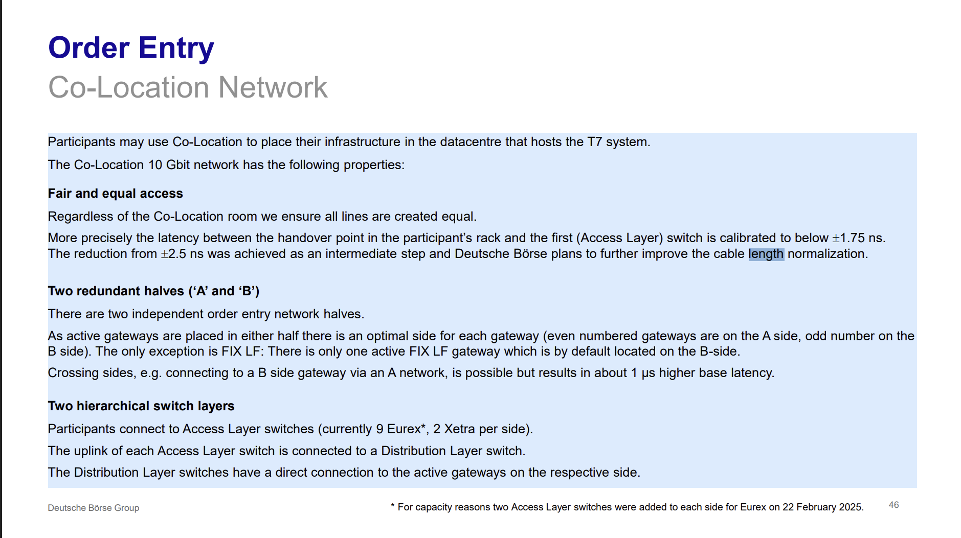

Co-Location Topology
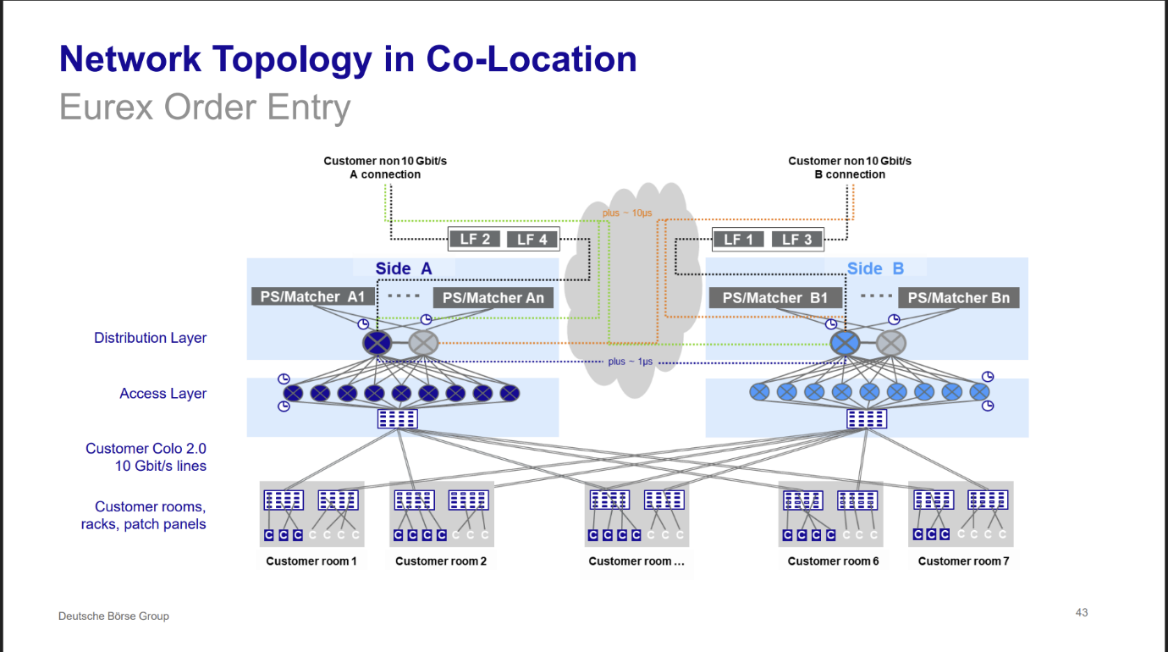

Gateway Types [PS and LF]
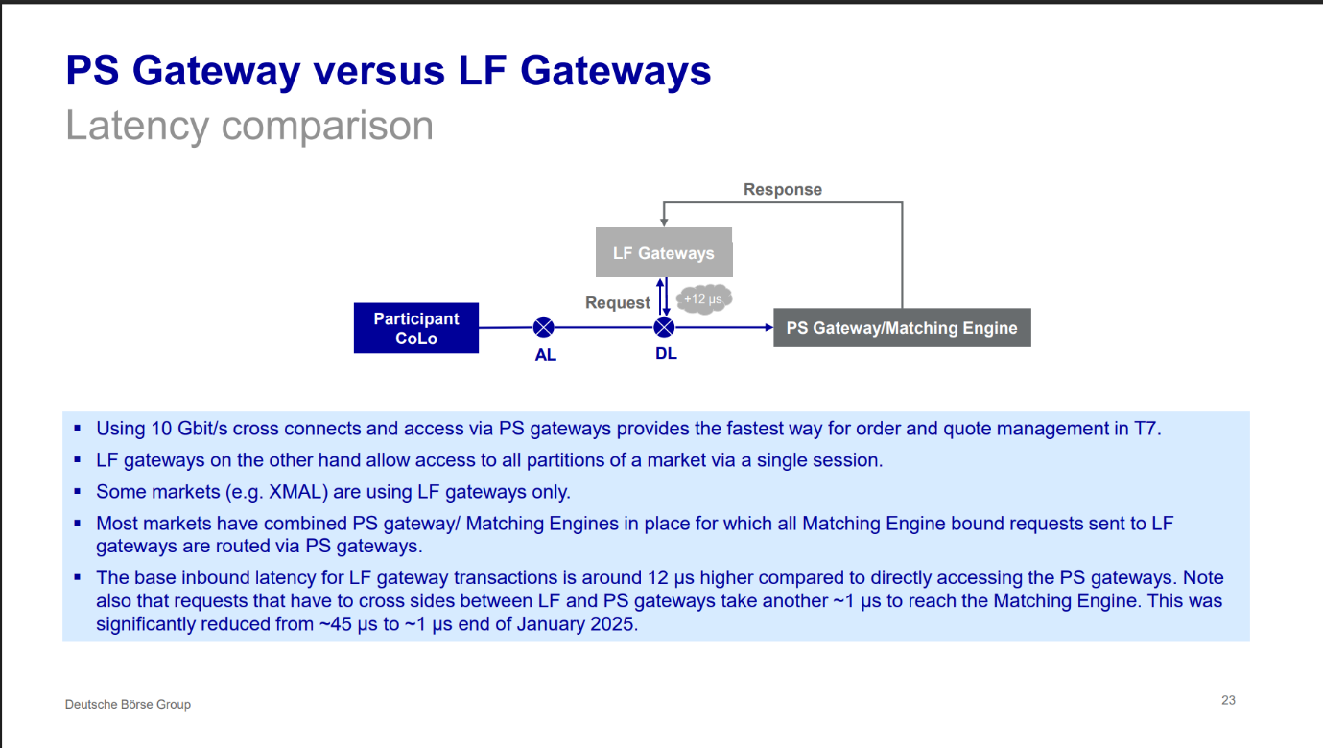

Order Entry Network
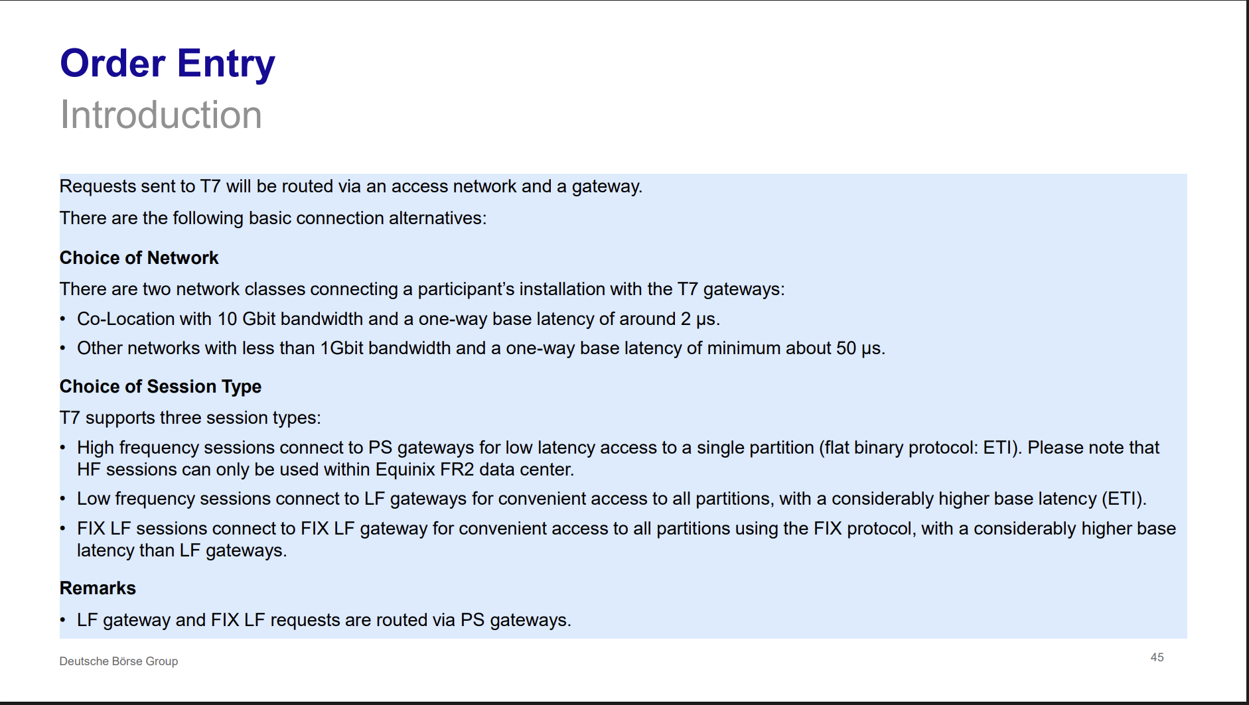

Market Data Networks
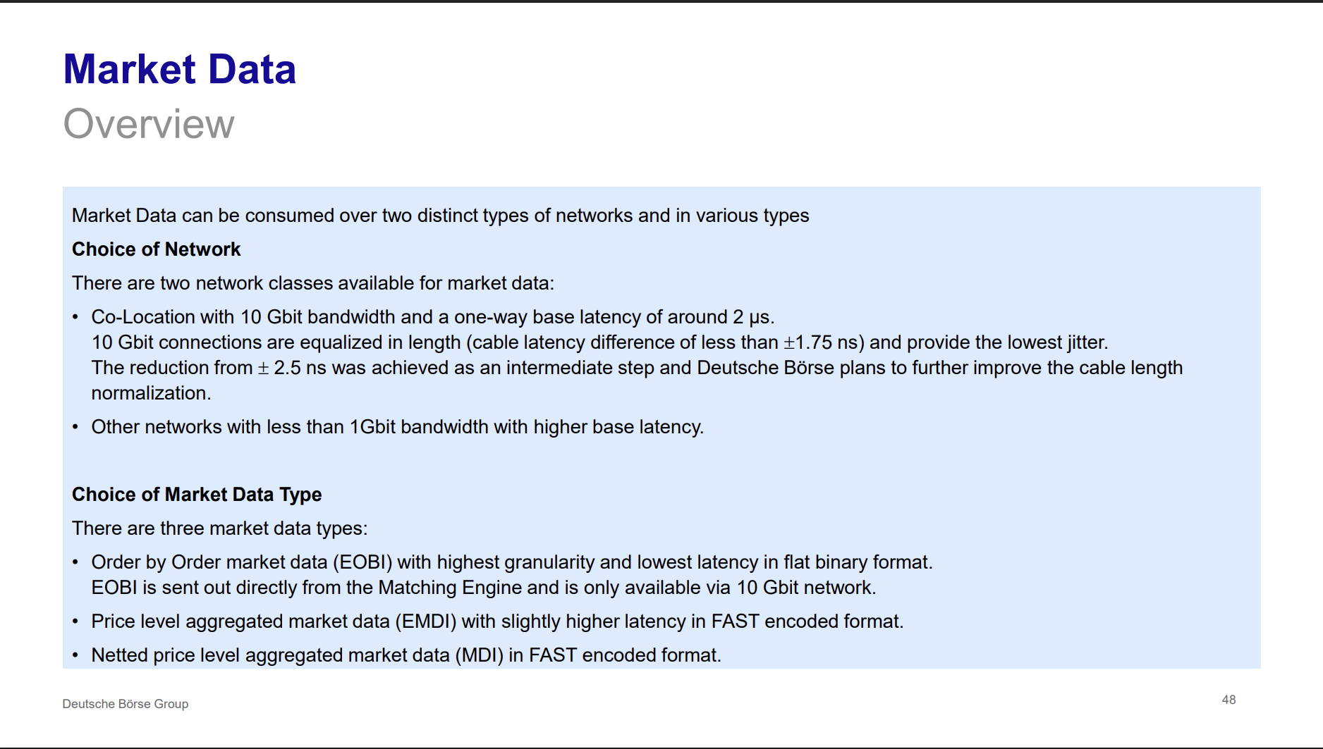

Order Entry Latency – Comparison of Access Types
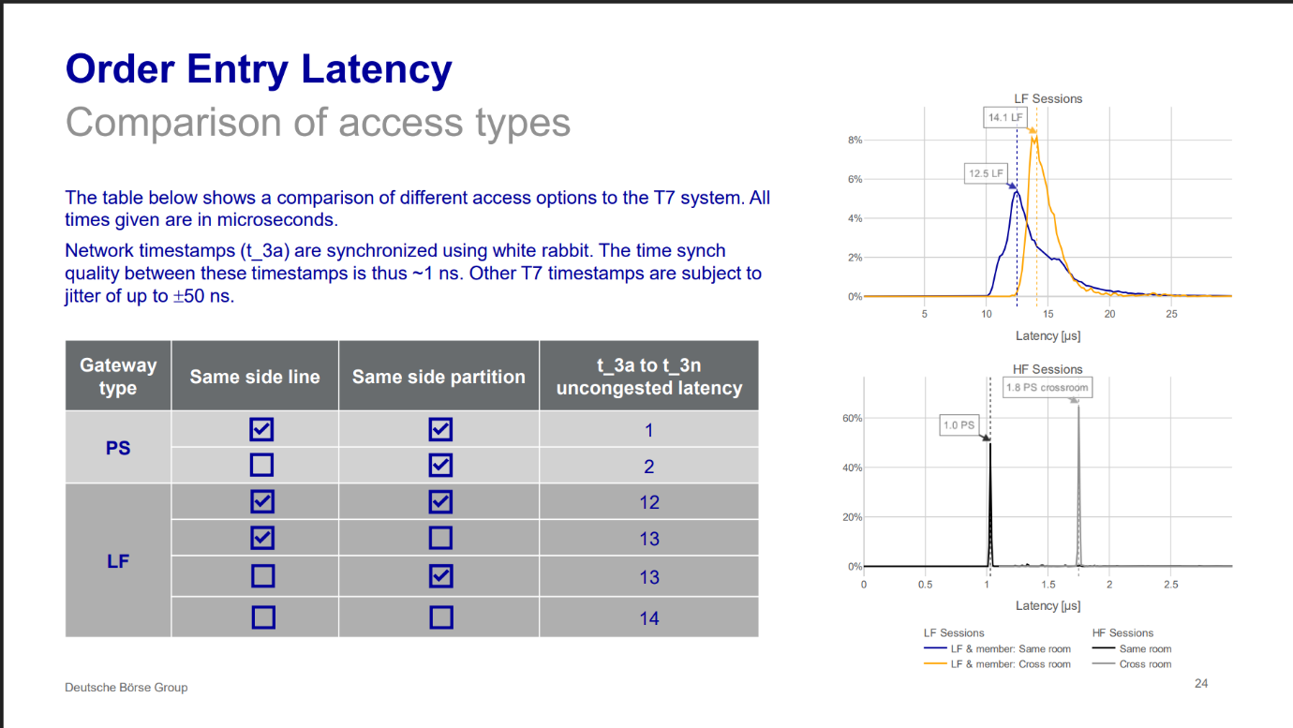

Recommendations for Speed
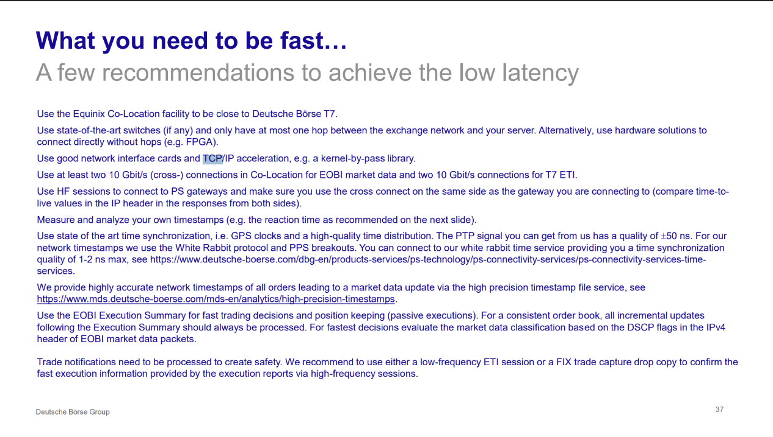

Algorithmic / HFT Trading Inherently Unfair

Recommendations

Order Entry - Gateways
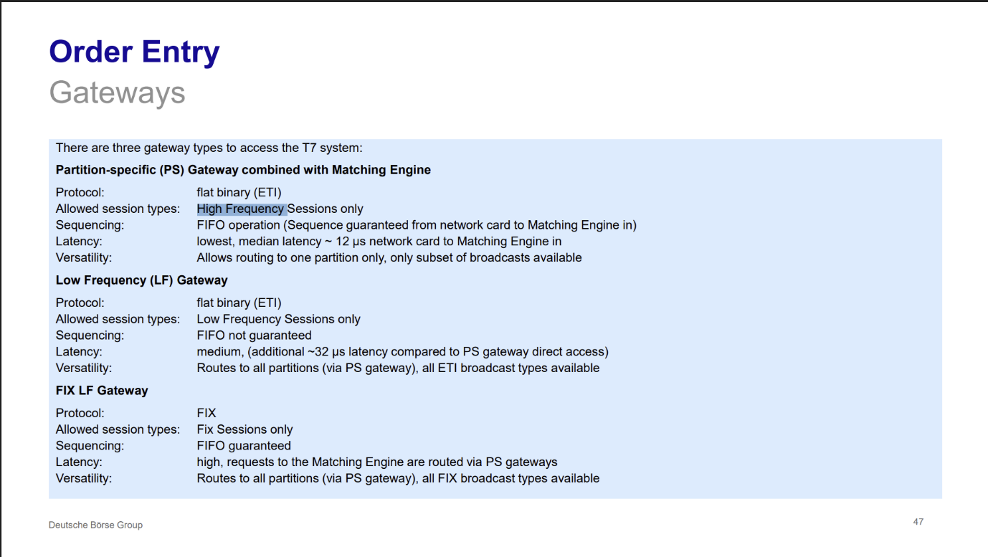

Order Entry - Introduction
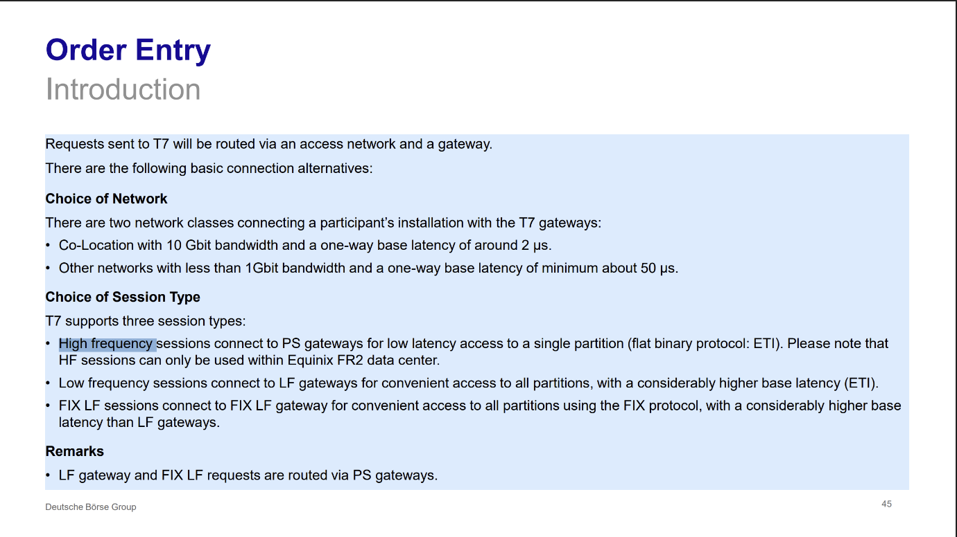

Latency Composition
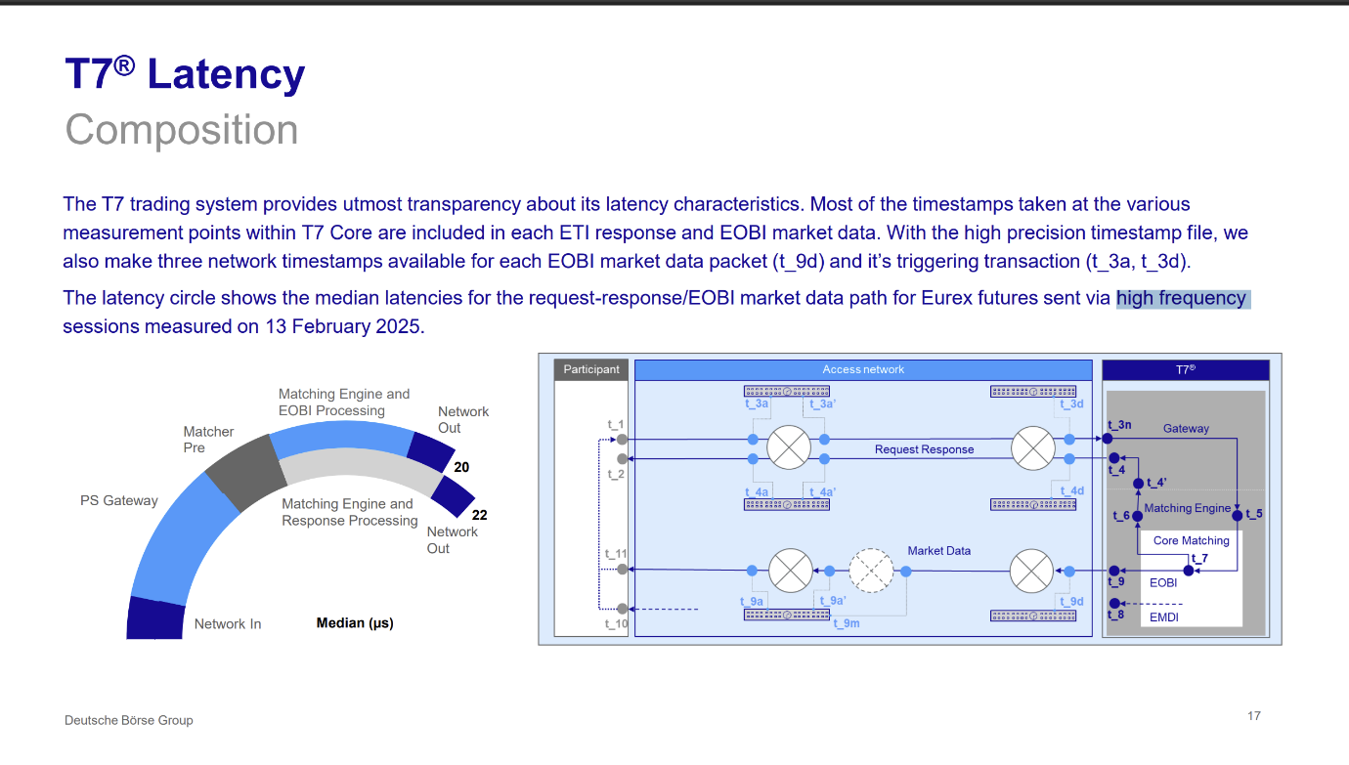

UDP vs TCP - Speed over Correctness

Timestamps - Description
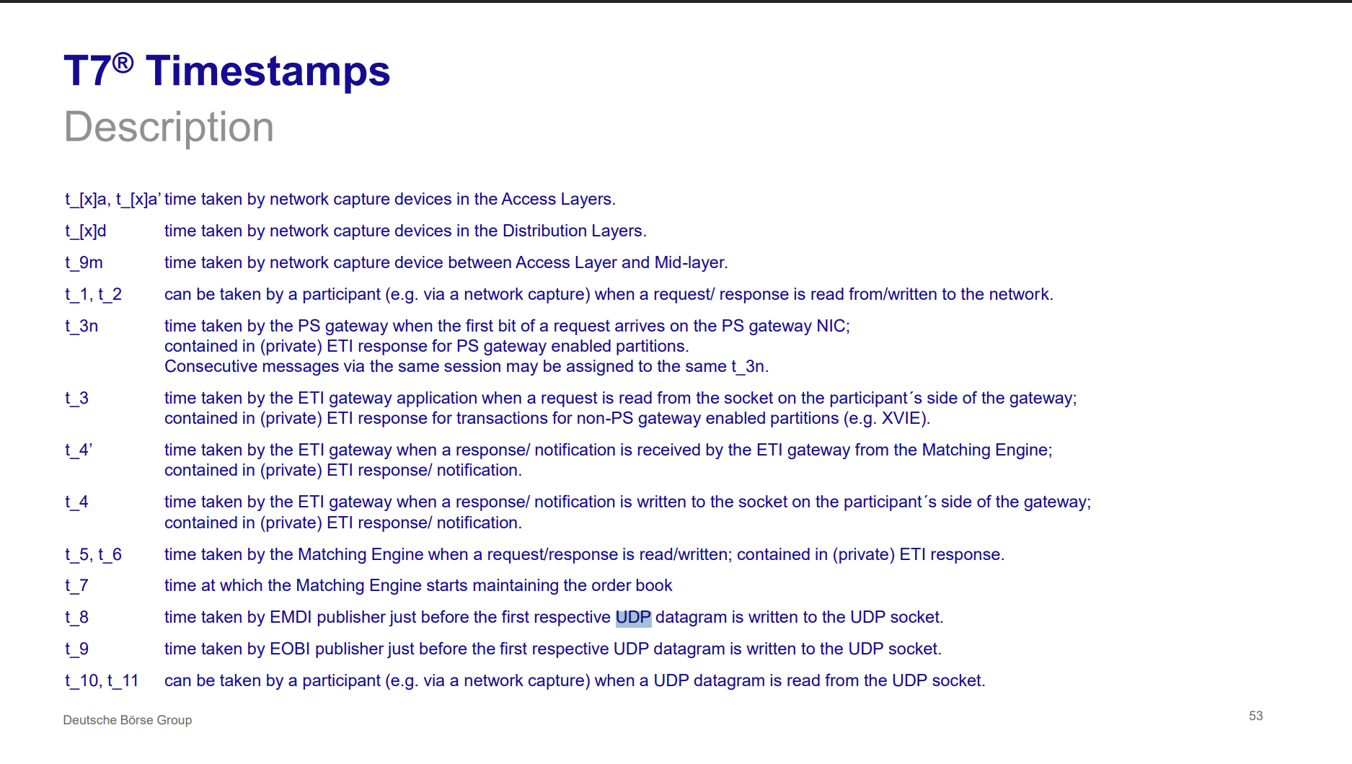

Timestamps – Reference
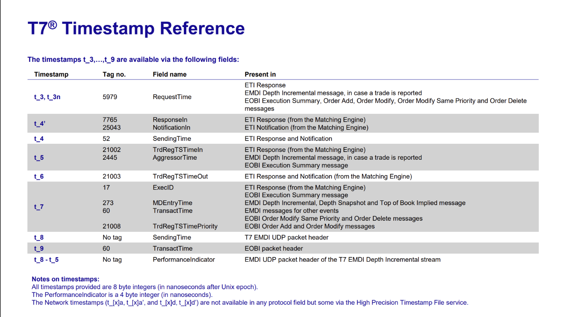

Latency Characteristics of ETI vs EOBI vs EMDI
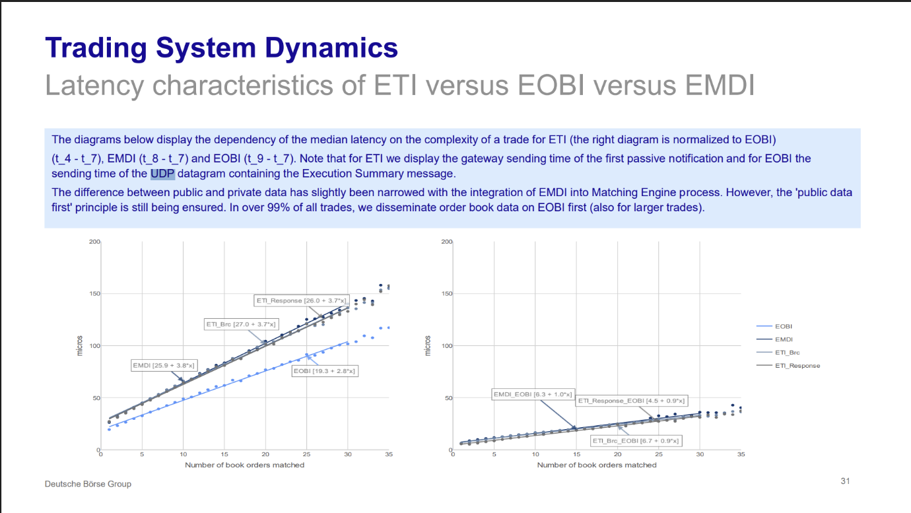

EOBI Latency of Primary and Secondary Feed
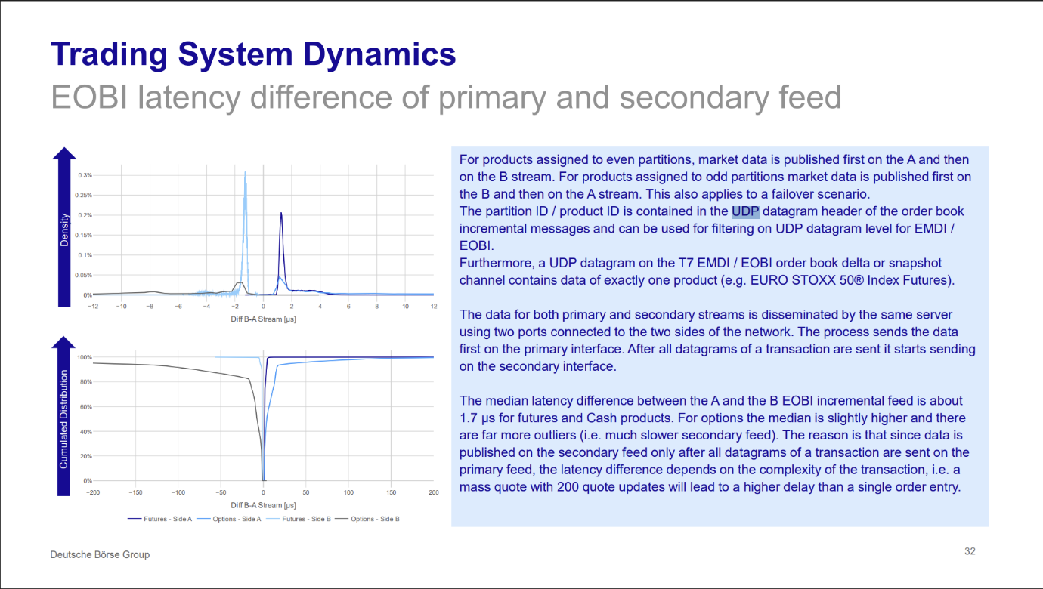

No Global State of the Market

Partitions
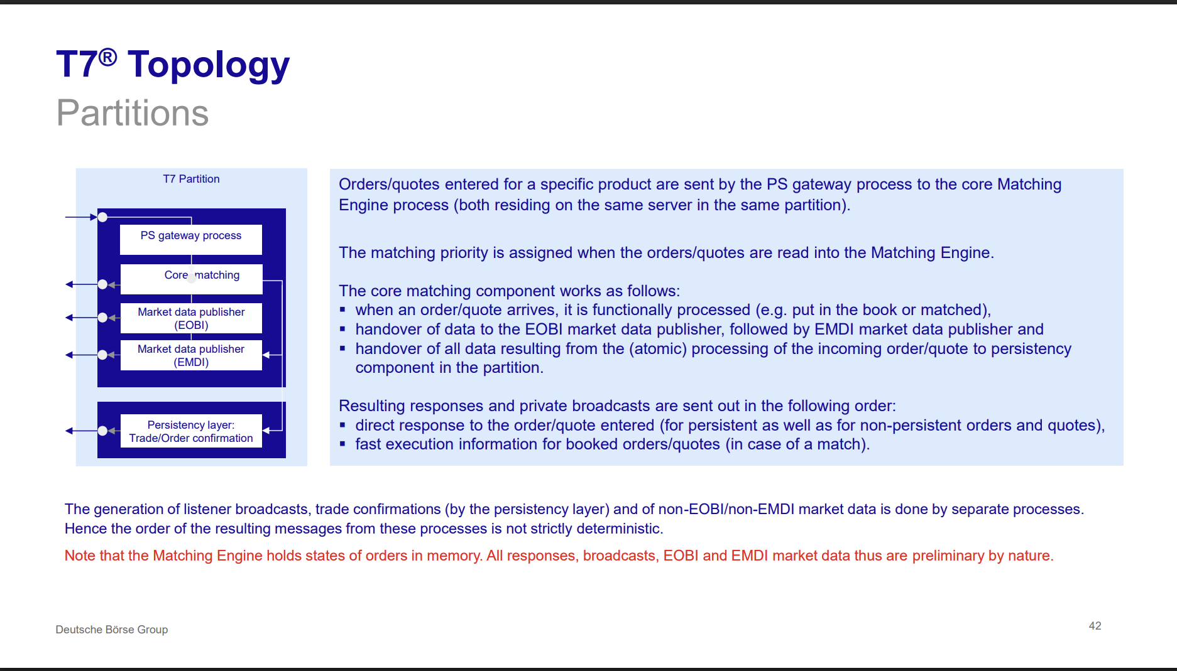

The "Public Data First" Gap

Latency Characteristics of EOBI vs ETI for Futures
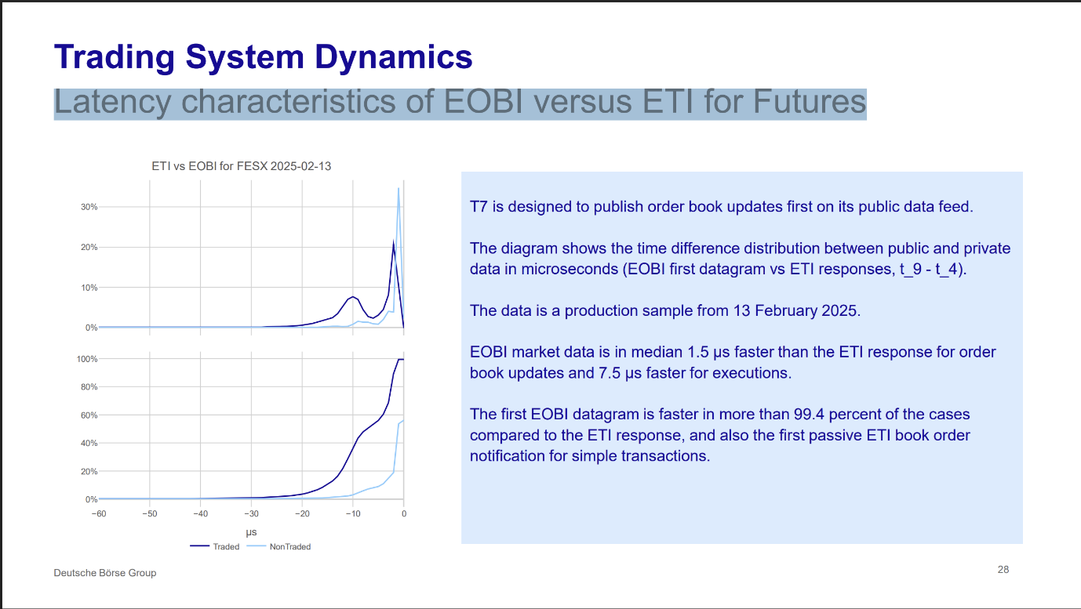

Bursts/Spikes

Eurex Micro-Burst Dynamics
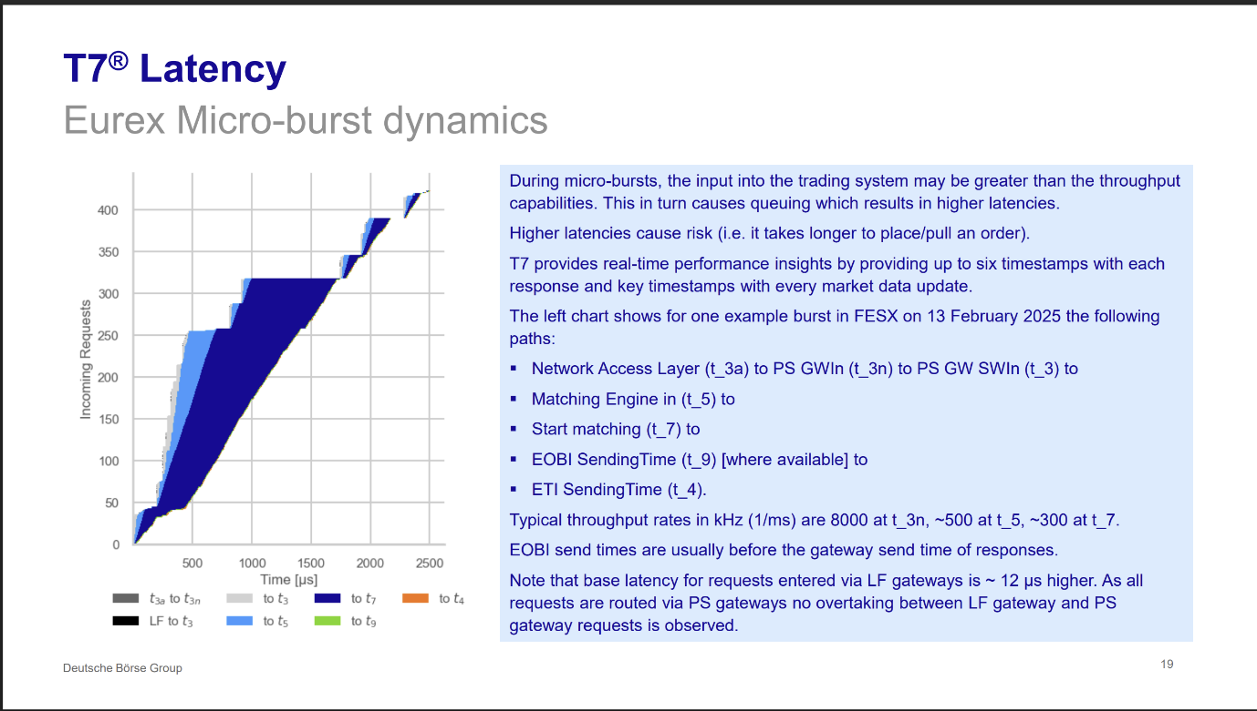
Xetra Micro-Burst Dynamics
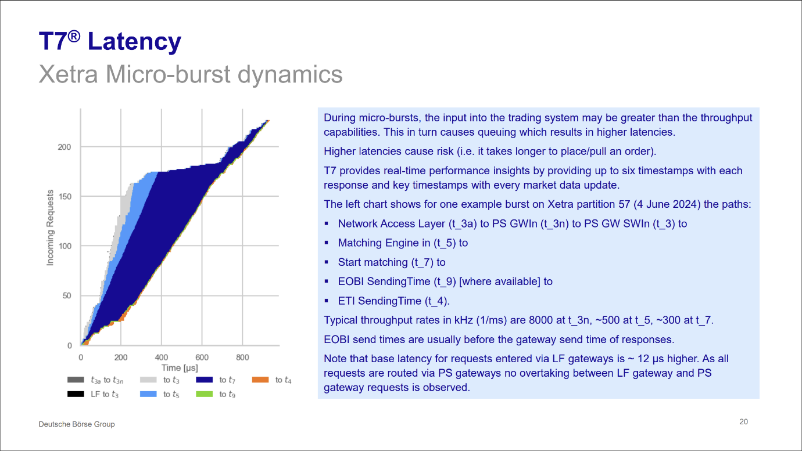

References
[1] https://upstox.com/help-center/what-are-the-benefits-of-using-the-tbt-tick-by-tick-tool-for-traders-263396/
[2] https://www.icsi.edu/media/webmodules/05092022_1NSE.pdf
[3] https://upstox.com/help-center/how-is-the-tick-by-tick-tbt-tool-different-from-the-standard-market-depth-view-263405/
[4] https://upstox.com/help-center/how-is-the-tick-by-tick-tbt-tool-different-from-the-standard-market-depth-view-263405/
[5] https://www.icsi.edu/media/webmodules/NSE_DARK_FIBRE_CO-LOCATION_CASE_SNAPSHOT.pdf
[6] https://community.upstox.com/t/india-s-1st-broker-to-offer-tick-by-tick-charting-data/3423
[7] https://upstox.com/news/upstox-originals/investing/tick-by-tick-trading-tbt-capture-every-market-move/article-118868/
[8] https://www.truedata.in/blog/levels-real-time-data-nse-bse-mcx
[9] https://upstox.com/news/upstox-originals/investing/tick-by-tick-trading-tbt-capture-every-market-move/article-118868/
[10] https://www.truedata.in/blog/understanding-tick-by-tick-data-benefits-and-challenges

